Personal Information Registration Form

I. Basic Information
1.Family Name: [Please fill in your family name here]
2.Given Name: [Please fill in your given name here]
3.Gender:
Male
Female
4.Nationality: [Please fill in your nationality]
5.Date of Birth: [Please fill in the format of year/month/day]
6.Place of Birth: [Please fill in the city and country of your birth]
7.Religious Belief: [Please fill in your religious belief, if any]
8.Email: [Please fill in your valid email address]

II. Academic Information
1.EGF Ranking: [If applicable, please fill in your EGF ranking]
2.Home Institution: [Please fill in the school, company or organization you currently belong to]
3.Major of Study: [Please fill in the name of your major]

III. Note
[Please fill in any information you need to supplement here, including allergy history (please specify allergens), and medical history (please briefly describe any major illnesses or chronic conditions).]

Ⅳ. Application material requirements
- ID Photo: The resolution of a 2-inch photo is 413 x 626 pixels with white background.
- Passport Homepage(Scan File Sample)
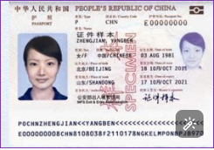
Please send the above two files together with the personal information registration form to 14010@gench.edu.cn

